// Methods.cpp : This file contains the 'main' function. Program execution begins and ends there.

//

// Code Created

#include <iostream>

using namespace std;

int main()

{

cout << "=========================" << endl;

cout << "\t" << "Welcome!" << endl;

cout << "=========================\n" << endl;

cout << "What is your name?" << endl;

cout << "Name: ";

string name;

cin >> name;

cout << "\n----------------------------\n" << endl;

cout << "How old are you?" << endl;

cout << "Age: ";

string age;

cin >> age;

cout << "\n----------------------------\n" << endl;

cout << "Hello, " << name << " who is " << age << " years old!";

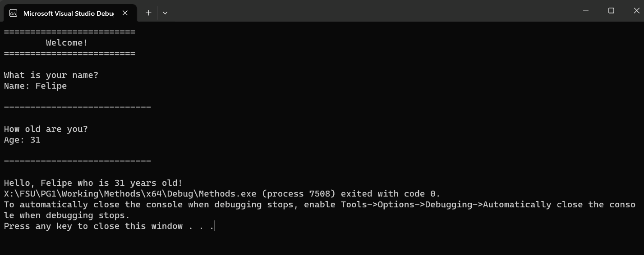

**// TODO: Create a method to reorganize some of your code**

#include <iostream>

using namespace std;

// TODO: Create a method to reorganize some of your code

void DisplayDivider() {

cout << "\n----------------------------\n" << endl;

}

string PromptUser(string primeMessage, string promptText) {

string response;

cout << primeMessage << endl;

cout << promptText << ": ";

cin >> response;

return response;

}

int main()

{

cout << "=========================" << endl;

cout << "\t" << "Welcome!" << endl;

cout << "=========================\n" << endl;

string name = PromptUser("What is your name?", "Name");

DisplayDivider();

string age = PromptUser("How old are you?", "Age");

DisplayDivider();

cout << "Hello, " << name << " who is " << age << " years old!";

